Practical 2 Selenium Testing

*Name: Niraj Thumar*

*Roll Number: 18BCE373.*

# Commands

1. **Open:** Opens a URL and waits for the page to load before proceeding. This accepts both relative and absolute URLs.
   * **arguments**
     1. url: The URL to open (may be relative or absolute).

1. **Set window size:** Set the browser's window size, including the browser's interface.
   * **arguments**
     1. resolution: Specify a window resolution using Width x Height. (e.g., 1500x800).

1. **Mouse over:** Simulates a user hovering a mouse over the specified element.
   * **arguments**
     1. locator: An element locator.

1. **Click:** Clicks on a target element (e.g., a link, button, checkbox, or radio button).
   * **arguments**
     1. locator: An element locator.

1. **Mouse out:** Simulates a user moving the mouse pointer away from the specified element.
   * **arguments**
     1. locator: An element locator.

1. **Type:** Sets the value of an input field, as though you typed it in. Can also be used to set the value of combo boxes, check boxes, etc. In these cases, value should be the value of the option selected, not the visible text. Chrome only: If a file path is given it will be uploaded to the input (for type=file), NOTE: XPath locators are not supported.
   * **arguments**
     1. locator: An element locator.
     2. value: The value to input.

1. **Mouse down at:** Simulates a user pressing the left mouse button (without releasing it yet) at the specified location.
   * **arguments**
     1. locator: An element locator.
     2. coord string: Specifies the x,y position (e.g., - 10,20) of the mouse event relative to the element found from a locator.

1. **Mouse move at:** Simulates a user pressing the mouse button (without releasing it yet) on the specified element.
   * **arguments**
     1. locator: An element locator.
     2. coord string: Specifies the x,y position (e.g., - 10,20) of the mouse event relative to the element found from a locator.

1. **Mouse up at:** Simulates the event that occurs when the user releases the mouse button (e.g., stops holding the button down) at the specified location.
   * **arguments**
     1. locator: An element locator.
     2. coord string: Specifies the x,y position (e.g., - 10,20) of the mouse event relative to the element found from a locator.

1. **Run script:** Creates a new "script" tag in the body of the current test window, and adds the specified text into the body of the command. Beware that JS exceptions thrown in these script tags aren't managed by Selenium, so you should probably wrap your script in try/catch blocks if there is any chance that the script will throw an exception.
   * **arguments**
     1. script: The JavaScript snippet to run.

1. **Select:** Select an element from a drop-down menu using an option locator. Option locators provide different ways of specifying a select element (e.g., label=, value=, id=, index=). If no option locator prefix is provided, a match on the label will be attempted.
   * **arguments**
     1. select locator: An element locator identifying a drop-down menu.
     2. option: An option locator, typically just an option label (e.g. "John Smith").

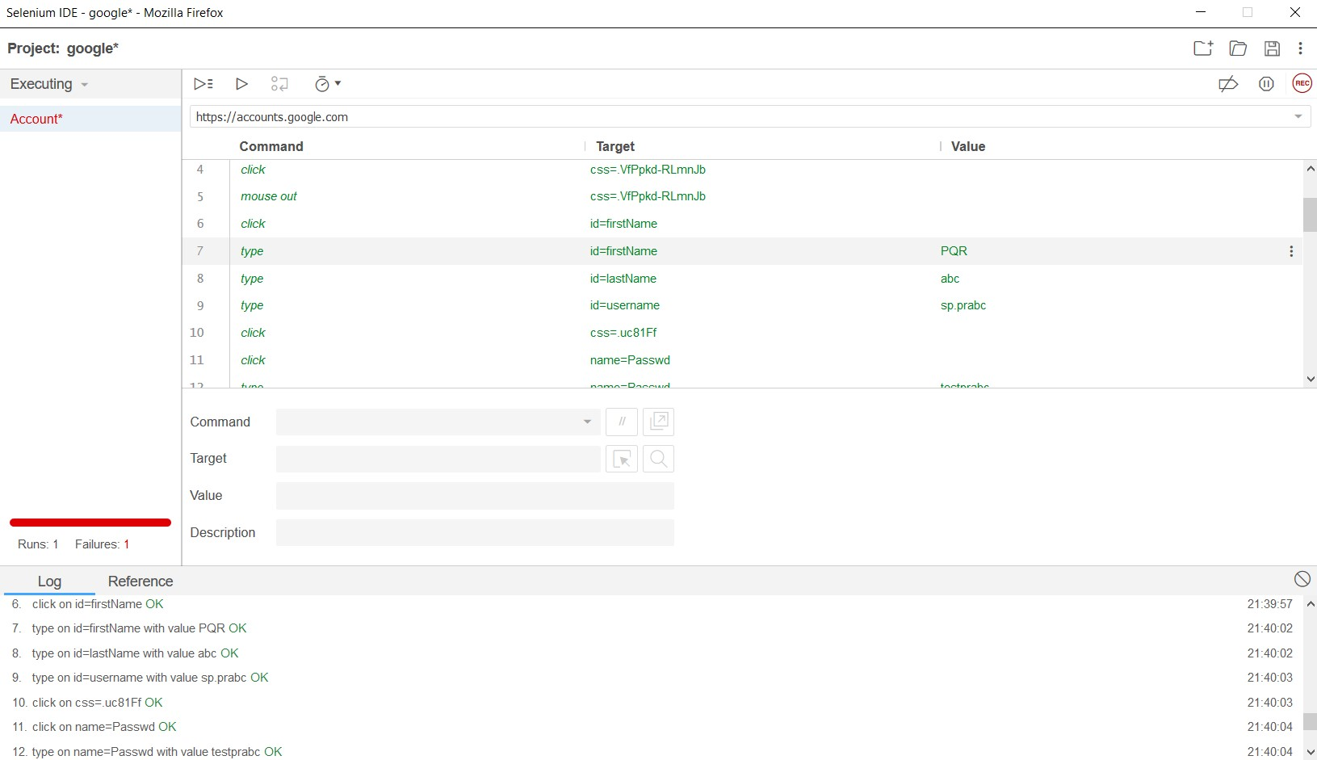

## [FIG: SELENIUM RUN ON ACCOUNTS.GOOGLE.COM]